**Assumption**: make sure you have the Java 8 JDK installed

**Install Scala/Spark on Local**

Step1: Download latest version of scala from **https://scala-lang.org/download/** then as per your OS install the version.

Step2: For windows, msi installer will be doing all things Also for Linux/Ubuntu, rpm will be doing the same.

Step3: For windows follow

* go to my computer/PC and left click on that.
* select properties --> Advance System Settings -> Advance tab --> Environment variables --> System variables --> path
* Edit the path and click on new.
* After this, provide path of scala till bin. for ex (C:\Program Files (x86)\scala\bin)

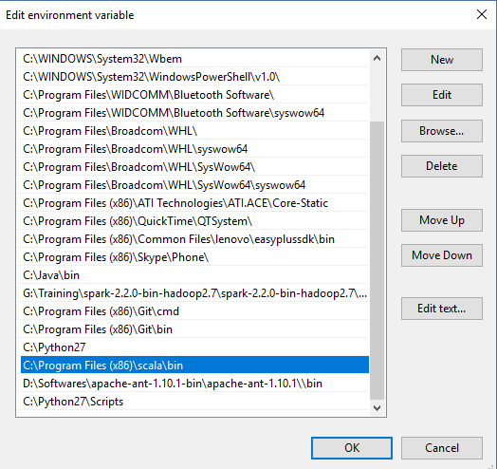

* Say ok multiple times until all windows are closed.

Step 4: Go to command prompt (run) and type "scala".

Step 5: Scala prompt will open, installation **successful**.

Step 6: After Scala, let’s start with Spark. Download Spark from below;

https://spark.apache.org/downloads.html

Step 7: Extract the folder downloaded.

Step 8: Spark has dependency on winutils. So copy and paste the **winutils** folder from **Google drive** --> Spark Installations and extract it locally.

Step 9: For windows follow

* Go to my computer/PC and left click on that.
* Select properties --> Advance System Settings -> Advance tab --> Environment variables --> System variables --> path
* Edit the path and click on new "user variables for Home" , add new variable as shown below :

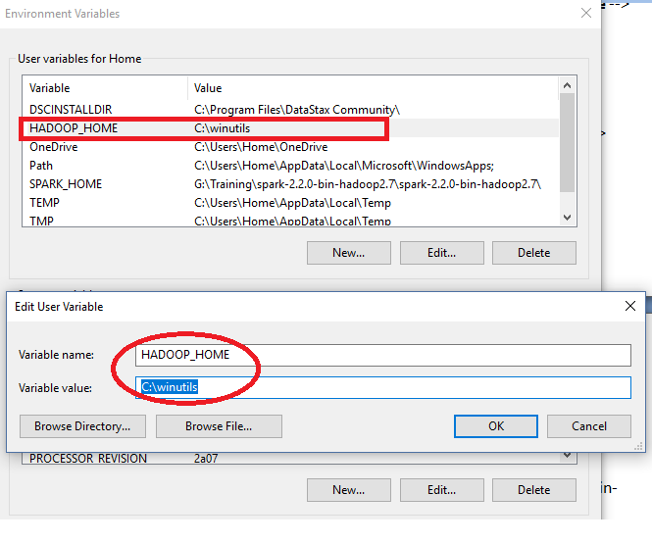

* After this, provide path of spark till bin. for ex (C:\Program Files (x86)\spark\spark-2.2.0-bin-hadoop2.7\bin) as below :

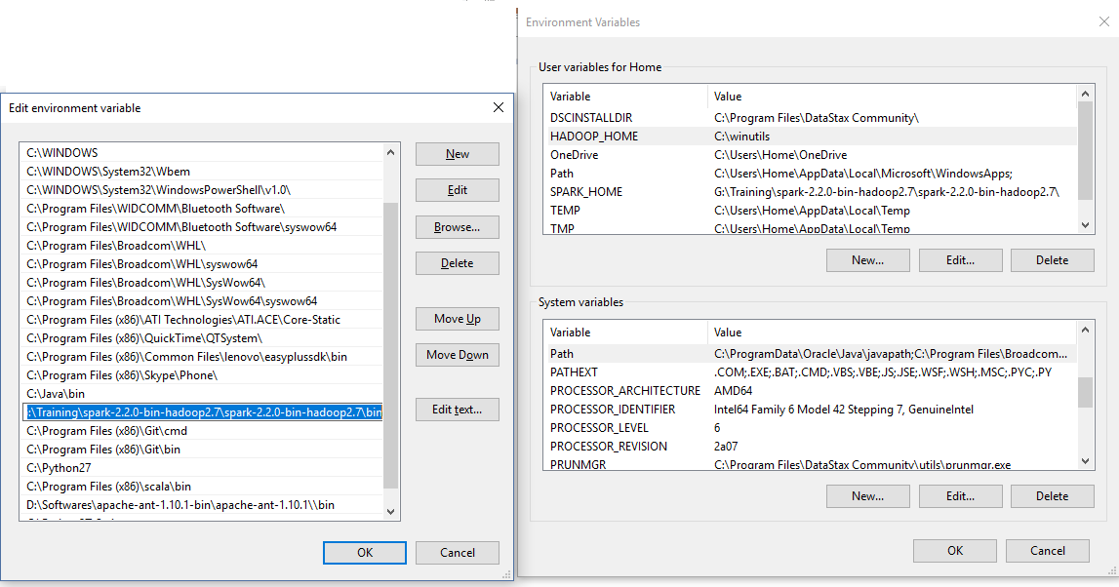

* Say ok multiple times until all windows are closed.

Step 9: Open command prompt, and say “**Spark-shell**” to play with scala version of Spark or “**pyspark**” to play with Python.